Unlock the Magic: Transform Any Image into Text Instantly

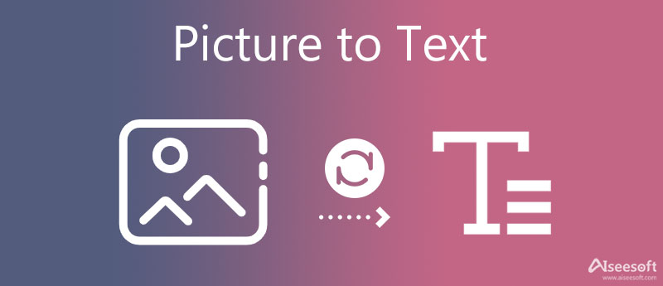

In today's digital world, where information flows in various forms, the ability to transform an image into editable text instantly is a game-changer. Whether for personal use or professional tasks, having the power to extract text from an image opens up countless opportunities for convenience and efficiency. **Optical Character Recognition (OCR)** technology, the driving force behind this transformation, has made it incredibly simple to convert printed or handwritten content into digital form with minimal effort. This article explores how this innovative process works, its various applications, and how you can harness its capabilities to boost your productivity.

**What is Optical Character Recognition (OCR)?**

At its core, **Optical Character Recognition (OCR)** is a technology that scans images, such as photos of documents, signs, or printed [Image to Text Converter](https://www.texttoimage.pro/) text, and converts the visual content into machine-readable text. By identifying characters and words within the image, OCR allows users to extract information with remarkable accuracy and speed.

OCR uses algorithms to analyze the structure of the image, recognizing different fonts, styles, and even handwriting, to extract the text. The process may involve several stages, such as image pre-processing, character segmentation, recognition, and post-processing, ensuring that the output is as accurate and readable as possible.

**The Evolution of OCR Technology**

OCR technology has come a long way since its inception. Early versions of OCR systems were simple and could only recognize basic printed characters. However, with advancements in machine learning, artificial intelligence (AI), and neural networks, modern OCR systems have become far more sophisticated. Today, OCR can handle complex images, different languages, diverse fonts, and even cursive handwriting.

This evolution has enabled a wide range of applications across multiple sectors, including education, healthcare, business, legal, and more. The continuous improvement of OCR technology has enhanced accuracy, speed, and versatility, making it indispensable in many workflows.

**How Does OCR Work? A Step-by-Step Process**

Understanding how OCR works can help users better appreciate its power and capabilities. Here's a breakdown of the OCR process:

**1. Image Pre-Processing**

Before any text extraction occurs, the image is pre-processed to improve its quality. This step typically involves adjusting the brightness, contrast, and resolution of the image to make the text clearer and easier to recognize. In some cases, techniques like de-skewing (correcting the angle of tilted images) or removing noise (unwanted marks or distortions) are employed to enhance accuracy.

**2. Text Detection**

Once the image has been pre-processed, the OCR system detects areas where text is present. This is a crucial step, as not all parts of the image may contain readable text. The system uses algorithms to identify and isolate blocks of text, whether they are simple paragraphs or complex layouts.

**3. Character Segmentation**

After detecting the text, OCR breaks down the image into individual characters or words. Character segmentation is essential because the system must recognize each character separately to reconstruct the full text accurately. In more advanced systems, this process also handles challenges such as characters that are close together or overlapping.

**4. Character Recognition**

In this stage, the OCR system applies algorithms to recognize the characters in the image. Depending on the sophistication of the system, this recognition process may involve the use of machine learning models, which have been trained on vast datasets of fonts and handwriting styles. The system compares the detected shapes to patterns it has learned to accurately identify each character.

**5. Post-Processing and Output Generation**

Once the characters have been recognized, the OCR software compiles them into a cohesive text document. This is followed by post-processing to correct any errors and improve the text's formatting. The output can be generated in various file formats, such as plain text (.txt), Word documents (.docx), PDFs, or even structured formats like Excel (.xlsx).

**Why OCR is a Game-Changer**

OCR is a revolutionary technology that brings a multitude of benefits to users across industries. Here are some of the reasons why OCR is a game-changer:

**1. Time Efficiency**

One of the most significant advantages of OCR is the speed at which it can convert images into text. Instead of manually typing out text from an image, which can be a tedious and error-prone process, OCR allows users to instantly extract text, saving valuable time and effort.

**2. Accuracy**

Modern OCR systems offer exceptional accuracy, even in challenging conditions. Advanced OCR tools can recognize various fonts, symbols, and handwriting styles, ensuring high-quality results. As AI and machine learning algorithms improve, OCR systems continue to become more adept at handling even the most complex images.

**3. Cost-Effectiveness**

OCR reduces the need for manual data entry, making it a cost-effective solution for businesses. By automating the process of converting image-based text into editable digital format, organizations can reduce labor costs, minimize human errors, and increase overall efficiency.

**4. Increased Productivity**

By converting printed or handwritten text into digital form, OCR makes it easier to store, search, and manage information. Whether you're scanning paper documents for archiving or converting images into editable files for further use, OCR can significantly enhance productivity across various tasks.

**5. Enhanced Accessibility**

OCR technology can also aid individuals with disabilities, particularly those with visual impairments. By converting printed text into machine-readable formats, OCR allows for the use of screen readers and other assistive technologies, making information more accessible to everyone.

**Applications of OCR Technology**

OCR technology has a vast range of applications across various fields. Some notable uses include:

**1. Document Management and Digitization**

OCR plays a critical role in document management systems, enabling businesses and organizations to digitize paper records. By converting printed materials into searchable digital files, OCR helps streamline workflows and improve document retrieval times.

**2. Data Entry Automation**

In industries like finance, healthcare, and insurance, OCR is used to automate data entry tasks. For instance, OCR can extract information from invoices, forms, and receipts, reducing the need for manual input and minimizing human error.

**3. Text Translation**

OCR can be integrated with translation software to provide quick translations of printed documents. This is particularly useful for travelers, businesses, and organizations working in multilingual environments, enabling them to understand foreign language text instantly.

**4. License Plate Recognition**

OCR is widely used in **Automatic Number Plate Recognition (ANPR)** systems, which are employed in traffic management, security, and toll collection. By recognizing license plates, OCR can help automate vehicle tracking and law enforcement activities.

**5. Handwriting Recognition**

While OCR is known for recognizing printed text, advanced systems can also handle handwritten content. Handwriting recognition can be particularly beneficial in converting handwritten notes, forms, and other documents into digital text.

**How to Transform Any Image into Text Using OCR**

There are several ways to convert an image into text using OCR. The process is simple, and numerous OCR tools are available online and as software solutions. Here’s a basic guide on how to do it:

**1. Select an OCR Tool**

Choose an OCR tool or software that suits your needs. Some popular options include **Google Keep**, **Adobe Acrobat**, **Tesseract**, and **ABBYY FineReader**. Many of these tools offer both free and premium versions, depending on the features you need.

**2. Upload Your Image**

Once you've selected an OCR tool, upload the image you want to convert. Most OCR tools support a variety of image formats, including JPG, PNG, TIFF, and PDF.

**3. Start the OCR Process**

After uploading the image, initiate the OCR process. The tool will analyze the image, recognize the text, and convert it into a digital format.

**4. Edit and Save**

Once the OCR process is complete, you can review the text for any errors. Many OCR tools allow you to edit the extracted text before saving or exporting it to your preferred file format.

**Conclusion**

OCR technology has transformed the way we interact with images and text. By allowing us to convert any image into editable and searchable text instantly, OCR has revolutionized industries ranging from document management to data entry automation. With continuous advancements in AI and machine learning, OCR systems are becoming more accurate and versatile, enabling users to unlock the magic of transforming images into text quickly and efficiently. Whether you're looking to digitize old documents, automate data entry, or simply make text more accessible, OCR offers a powerful solution to meet your needs.